Date: 18.04.2024

**TITLE**

**TASK**

**CS 6301 - Machine Learning Lab - Week 13**

**IMPLEMENTATION OF DECISION TREE ALGORITHM**

1. The table below shows factors that would aid a player to play Golf or not. Build a Decision Tree model that could predict whether a player would play or not with implementation in Python. Build the model manually and verify the same with code.

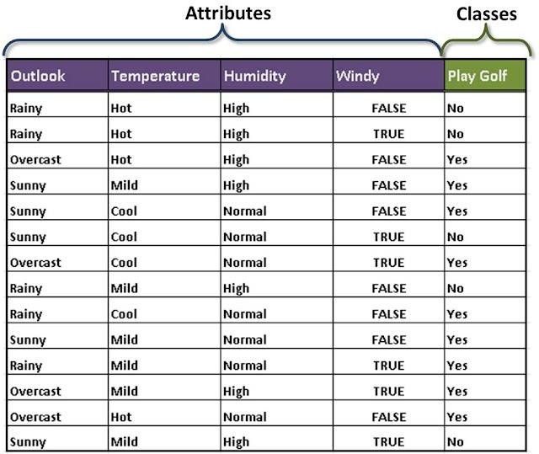

* 1. When do we perform splitting of a Decision Tree Node and how?
  2. What can be understood from Entropy and Information Gain?

1. Data Set Description: Data Filename: data4_19.csv The data set contains 150 data points, there are three classes where each class refers to a type of iris plant. The first four columns represent the attributes listed below. Note that only the first four columns should be used as attributes. The last column is the ground truth class name.

1. sepal length in cm 2. sepal width in cm 3. petal length in cm 4. petal width in cm 5. Ground truth class name: -- Iris Setosa -- Iris Versicolour -- Iris Virginica

Write Python code to implement Decision Tree for this dataset and find the species of the new flower given Sepal length= 5.2, Sepal width =3.1, Petal length= 1.4, Petal width =0.2.